**Assignment -**

**4**

|  |  |
| --- | --- |
| Assignment Date | 10 NOVEMBER 2022 |
| Student Name | MONISHA R |
| ROLL NO. | 412419104066 |
| PROJECT | Emerging Methods for Early Detection of Forest Fires |

**Question 1:**

**Pull an image from docker hub and run it in docker playground.**

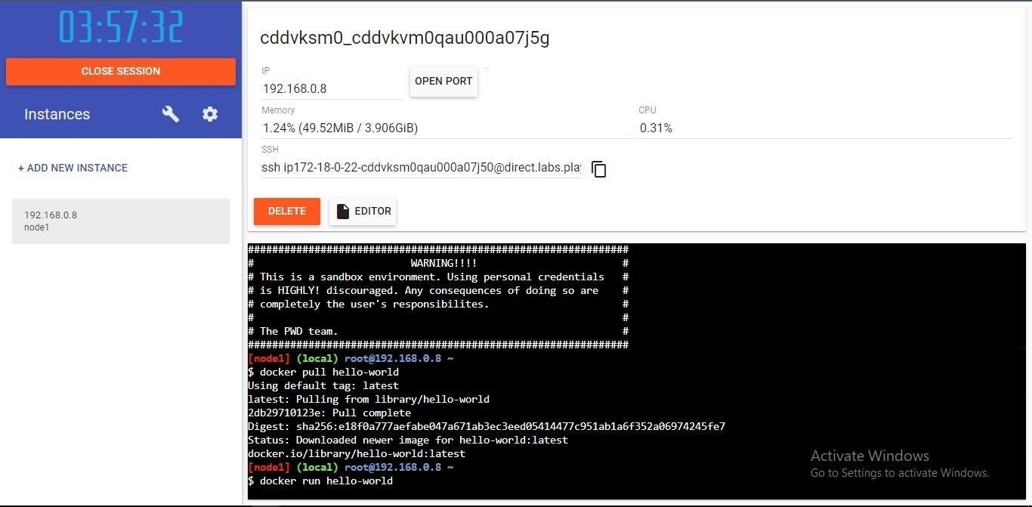

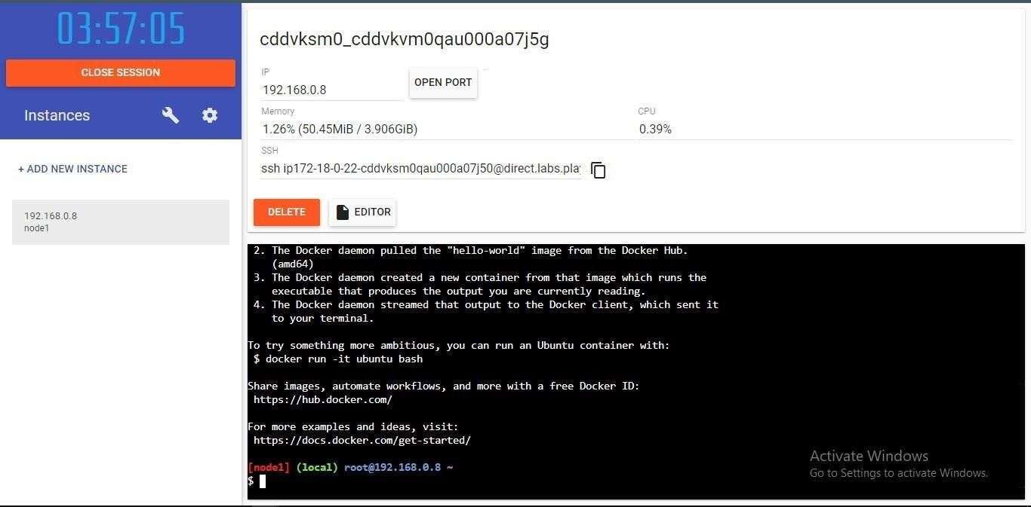

**Question 2:**

**Create a docker file for the job portal application and deploy it in Docker desktopapplication**.

DOCKER FILE:

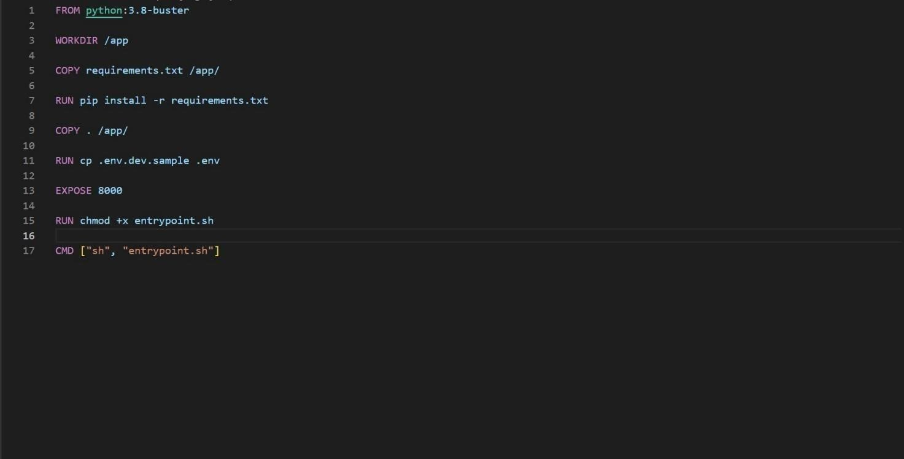

DEPLOYMENT OF JOBPORTAL APPLICATION:

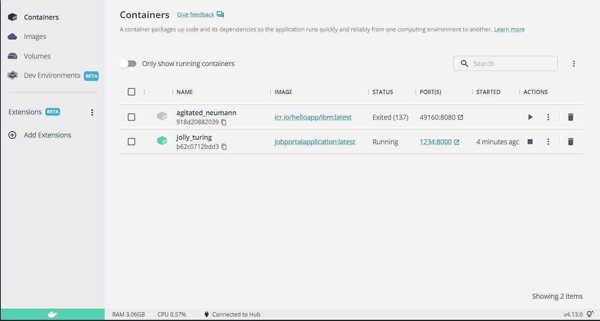

OUTPUT:

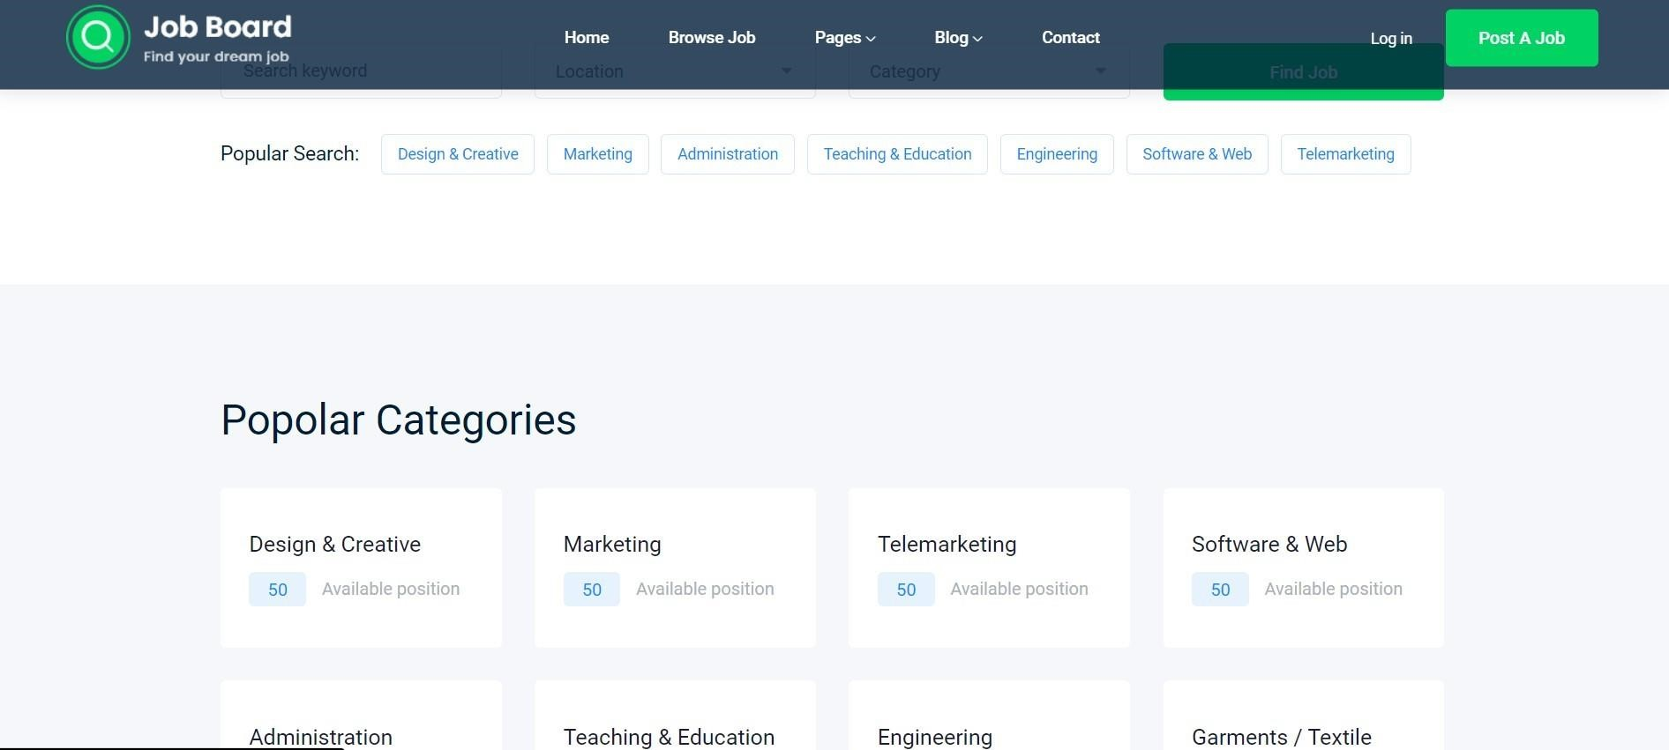

**Question 3:**

**Create a IBM container registry and deploy hello-world app or job port**

**app.IBM** CONTAINER REGISTRY DEPLOYMENT:

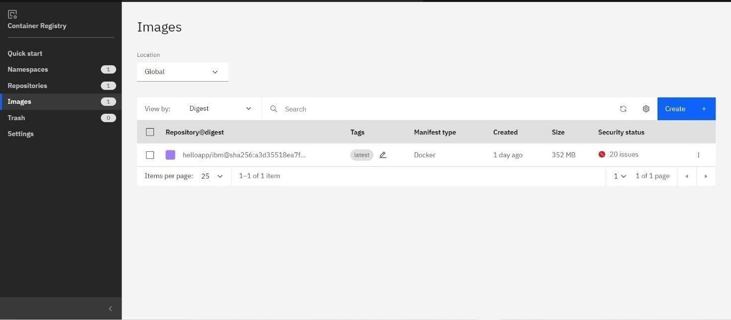

OUTPUT:



**Question 4:**

**Create a Kubernetes cluster in IBM cloud and deploy hello world image or job portal image and also expose the same app to run in node port.**

Creating Kubernetes cluster in IBM cloud and exposing node port:

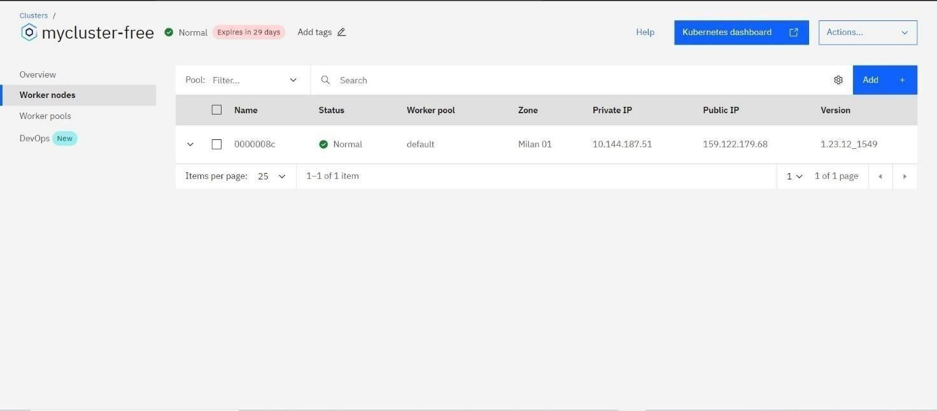

Output:

